Design of a Lock-In Amplifier:

# Group Members:

* Michelle Kim.
* Kelvin Paa Kwesi Adjei.

# Project Description:

A lock in amplifier is a device which filters out a small signal from a very noisy environment. The purpose of our project will be to use a lock in amplifier to filter out light coming from a small LED in a room filled with lights from different sources with different frequencies. The device should consist of a photodiode, a unity gain amplifier and a low pass filter designed as an RC circuit. It should be able to filter out the LED based on the principle of phase sensitive detection by singling out the signal being produced by the LED at a specific frequency and phase, and filtering out the rest of the signals coming into the device as noise.

To do so, the input signal is compared to a reference signal which has a frequency and phase equivalent to that of the signal we want to filter out from the input. The input and reference are then multiplied together and this results in an output signal which is equal to the average of the product of the amplitude of both the required signal and the reference signal. The product of the noise and the reference signal however results in a zero output since they have different frequencies and/or are out of phase. A low pass filter is then used to pick out the part of the signal that is correlated with the reference essentially by averaging the output of the mixer and this is the lock-in output. Lock in amplifiers are important in solving to signal-to-noise problems in research labs and they enable us to reduce noise associated with the measurement of physical properties of systems such as pressure, flow and temperature since these systems usually have properties with high noise- to- signal measurement ratios.

# Block Diagram

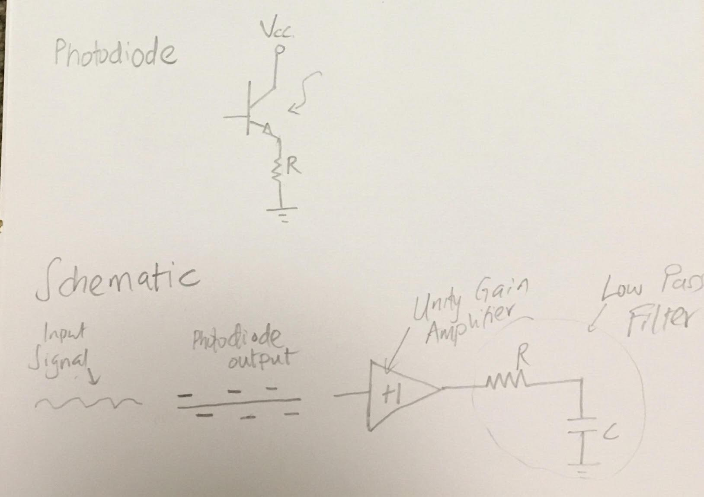

# 

# Weekly Schedule

* October 28th to November 1: Order any parts needed
* Nov 10-15: Start with design of lock in amplifier
* Nov 17-23: Complete Design of Lock in amplifier and make sure it works
* November 24-30 (Short week because of Thanksgiving): Complete Project report and Presentation Slides